**ACCIDENT LOCATION ANALYSIS & ENHANCING ROAD SAFETY**

10th Sep 2023

TEAM New Floraison (Rajalakshmi Institute of Technology)

1. Keerthana R – 3rd year AI&DS
2. Lokeshwaran S – 3rd year AI&DS
3. Satthish K – 3rd year AI&DS

**Abstract**

In this project, we are leveraging various data sources and advanced algorithms to enhance road safety and emergency response. Our dataset includes critical information such as alerts, date, time, GPS coordinates, vehicle details, and speed. The 'Alert' column contains valuable insights, including Forward Collision Warning (cas_fcw), Pedestrian Collision Warning (cas_pcw), Lane Departure Warning (cas_ldw), and Headway Monitoring (cas_hmw) alerts, enabling us to identify potential accident scenarios in real-time. To improve emergency response, we have integrated hospital data into our system, allowing us to identify the nearest hospitals using the shortest path algorithm. While Google Maps uses various algorithms, one commonly used is Dijkstra's algorithm, which efficiently calculates the shortest route between two points on a map. Additionally, we have integrated ambulance services into our system, ensuring that assistance can be dispatched promptly to accident locations. This integration is facilitated by utilizing datasets provided by Intel Corporation and QGIS software & Kepler GIS.

These datasets provide crucial information about road networks, traffic conditions, and hospital locations. Our approach enhances road safety by quickly identifying and responding to potential accidents. By combining real-time alerts, hospital proximity analysis, and ambulance service integration, we create a comprehensive solution that can significantly reduce emergency response times and ultimately save lives. Our project demonstrates the power of data integration, geographic information systems (GIS), and advanced algorithms in improving public safety on our roadways.

**Introduction**

In today's fast-paced world, road safety and efficient emergency response systems are paramount. Accidents, from minor collisions to life-threatening incidents, requires fast and well-organized responses to minimize harm and save lives. This research paper addresses these critical issues by employing a multifaceted approach, utilizing data-driven methodologies, advanced geospatial tools, and cutting-edge algorithms. The core dataset includes parameters like alert types (e.g., Forward Collision Warning, Pedestrian Collision Warning), incident date and time, geographic coordinates (lat and long), vehicle characteristics, and speed measurements, offering a comprehensive insight into road incidents for devising effective strategies. Our objective in this research involves integrating nearby hospital data using a shortest path algorithm, thereby optimizing response times to accidents and emergencies. We've collected, processed, and analysed hospital data within the targeted region to efficiently locate the nearest hospital to any accident site.

Additionally, ambulance service data has been incorporated to establish a dynamic and efficient response network. This is made possible through collaboration with the data given by Intel Corporation and the use of QGIS software. This research advances road safety and emergency management, aiming to enhance public safety, reduce accident-related casualties, and optimize emergency resource allocation, potentially revolutionizing emergency response systems and saving lives.

**Related Work**

In our previous research [Intel Project](https://devmesh.intel.com/users/keerthana-rajendran) within the domain of Accident Locations on Indian roads, we conducted a comprehensive study focusing on Tamil Nadu's road safety landscape. We collected extensive data and performed spatial analysis utilizing QGIS software. This research delved into the intricacies of accident occurrences, their distribution, and contributing factors within the Tamil Nadu region.

Our earlier work involved the compilation of accident data, including accident types, locations, and associated variables. Through spatial analysis, we discerned patterns, hotspot areas, and potential risk factors contributing to accidents. By leveraging the power of QGIS software, we visualized and quantified these insights, shedding light on the spatial dynamics of accidents on Tamil Nadu's road network. The insights gleaned from our prior research provide valuable context and groundwork for our current project, which seeks to enhance emergency response systems in the same region, building upon our prior spatial analysis expertise and dataset.

**Data Sources**

We acquired essential data from external sources to support the integration of hospital services and ambulance response. Hospital data in Chennai, Chengalpattu, Kanchipuram areas near the NH 32 were also systematically collected, focusing on locations provided by the organization. This dataset encompasses hospital names, precise geographical coordinates, and their capabilities in handling emergencies. Simultaneously, we collected comprehensive data on ambulance services operational in the region. This dual dataset, originating directly from hospitals and ambulance service providers, serves as the bedrock of our project, facilitating the efficient transportation of patients to the nearest hospitals and the optimization of emergency response systems in the Chennai area.

**Analysis**

As the dataset has been given by the company itself, we used this data for analysis. We have also used machine learning to analyse and visualize the data. By delving deeper into the data, we extracted more valuable and meaningful insights related to accident locations and road safety.

**1*.*Geospatial Analysis:**

By plotting the latitude and longitude coordinates on a map, we identified the specific accident-prone areas or intersections. These locations may require targeted safety measures such as improved signage, traffic calming, or enhanced enforcement.

**2. Speed and Alert Type Correlation:**

By correlating the speed and alert type, the cas_hmw i.e Headway Monitoring Warning is likely to be more over the speed. It tends to 12328 and this was a large data with 21000 entries of the given data. From this correlation we can infer that vehicles gives more cas_hmw alert when compared to other alerts.

**3. Vehicle and Alert Type correlation:**

By plotting the vehicle and alert type data, we can infer that the vehicle with vehicle id 805 has given 6875 alerts. This is considered as the maximum of alerts given by all the vehicles. The vehicle 805 has high probability to fall in accident.

**4. Count of Alert per Month:**

When plotting the Alert type and Date in the dataset, the inference gives a decreasing and an increasing slope which indicates that the alert given by the vehicles in July is comparatively less, because there is no much data in the field for July.

**5. Speed of Vehicles by Time:**

By plotting the Speed of Vehicles over Time, the graph is likely to be left skewed representing that the speed is increased with respect to time, expect the minimum speed i.e 0. The maximum speed of the vehicles is about 59m/s.

**6. Vehicle Vs Speed:**

The Vehicle Vs Speed column chart gives the relationship between the vehicle and speed over the data. The vehicle 2846 is comparatively high in speed, as its avg speed is 43.11m/s.

**7. Count of Alert:**

The Count of Alert pie chart indicates that most of the vehicles in our data give cas_hmw (Headway Monitoring) alert more than the other alerts. The drivers can focus more the headway monitoring that is vehicles or colliding items infront of their vehicle and can monitor the distances between the heading vehicle and their vehicle.

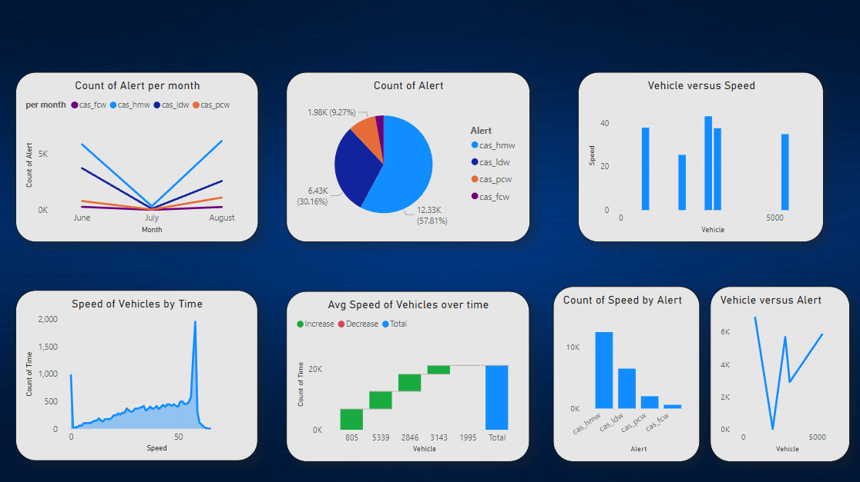

Fig.1 Insights got through analysis

These are some of the insights or patterns that we have collected or derived from the given dataset. Our analysis also includes Geospatial analysis in which we have plotted the latitude and longitude and gained a map marked with the alerted locations of the vehicles.

More than that we have also plotted the hospitals near the NH 32 road which comprises all the places that is covered in the given dataset. There are many hospitals located near our target and we can able to find the optimal one by using the shortest path algorithm. Here, we also plotted the Ambulance Service data that has been plotted in the map. This data helps us to enhance the response time whenever an accident has occurred.

Below you can see the plots that is marked with the help of QGIS (Quantum Geographic Information System) Software.

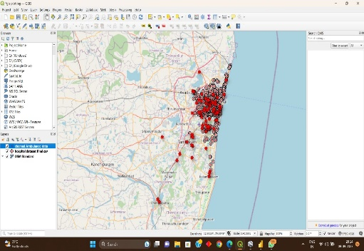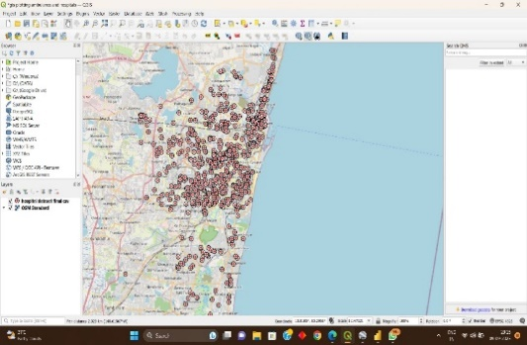

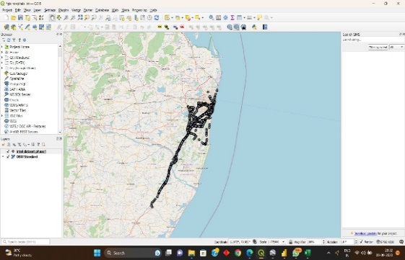

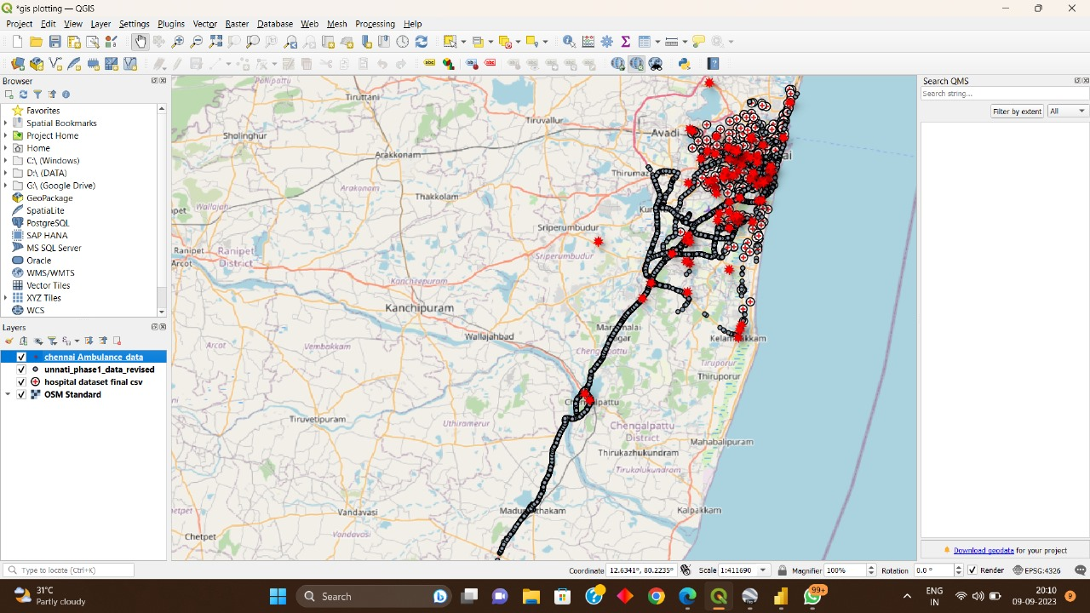

Fig.2 plotting of the given lat & long, Hospitals and Ambulance Service data

**References**

1. Accident Locations on Indian Roads, 2023. Intel Unnati Training Program.

2. Budiharto, U, Saido, A.P., 2012. Traffic accident blackspot identification and ambulance fastest route mobilization process for the cities.

3. K Gearts & G Wets, Black Spot Analysis Methods: Literature Review, 2003

4.Chen, H., 2012. Blackspot determination of accident locations & its spatial analysis based on GIS.

5. Gholam Ali Shafabakhsh, Afshin Famili, Mohammad Sadegh Bahadori., 2017. GIS – based spatial analysis of urban traffic accidents.

**URL’s or Links:**

GitHub **-** <https://github.com/lokeshwaran173/intelunnati-grand-challenge-winter-New-Floraison>

Google Drive - <https://drive.google.com/drive/folders/1ou0DQNtId9JaVMfLWRqmD8vWzWU8aZHv>

Our Related Project - <https://devmesh.intel.com/projects/blackspots-of-accident-locations-on-indian-roads>